CHARTING THE COURSE OF INNOVATION:A STARTUP ANALYSIS

Introduction:

Starting a new company can be an exciting and rewarding experience, but it also requires careful planning and analysis to ensure that the business is viable and successful. There are several key areas that you should focus on when conducting a startup company analysis.

Empathy Map: 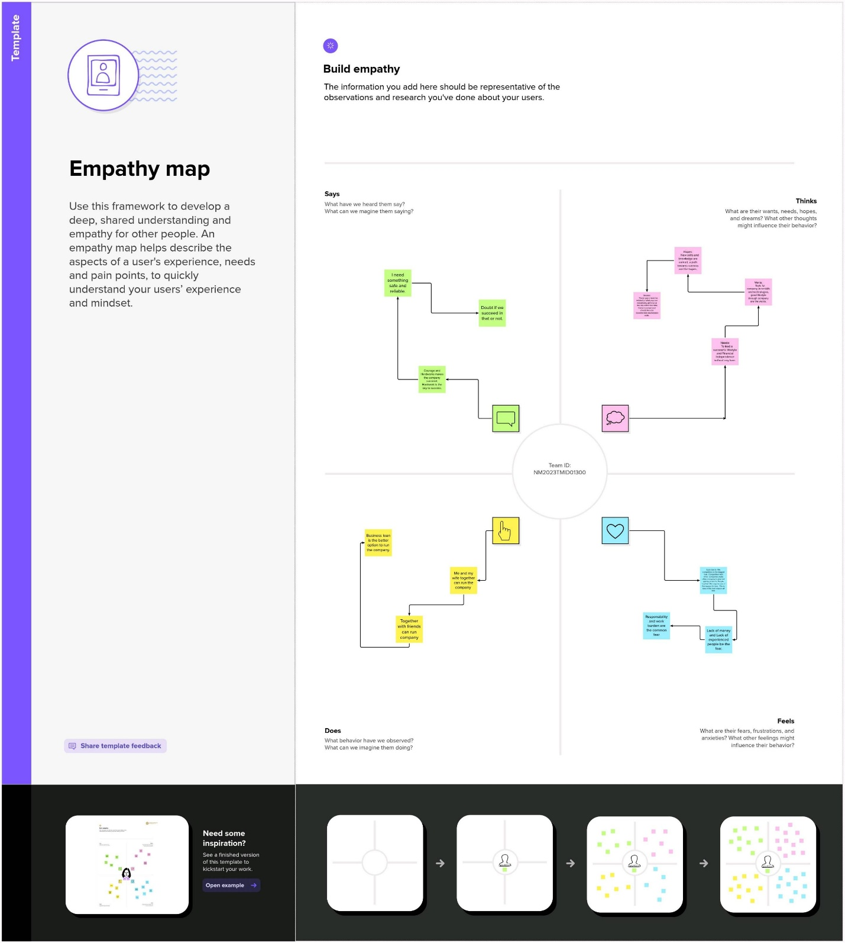

Brainstorming and Ideation Prioritization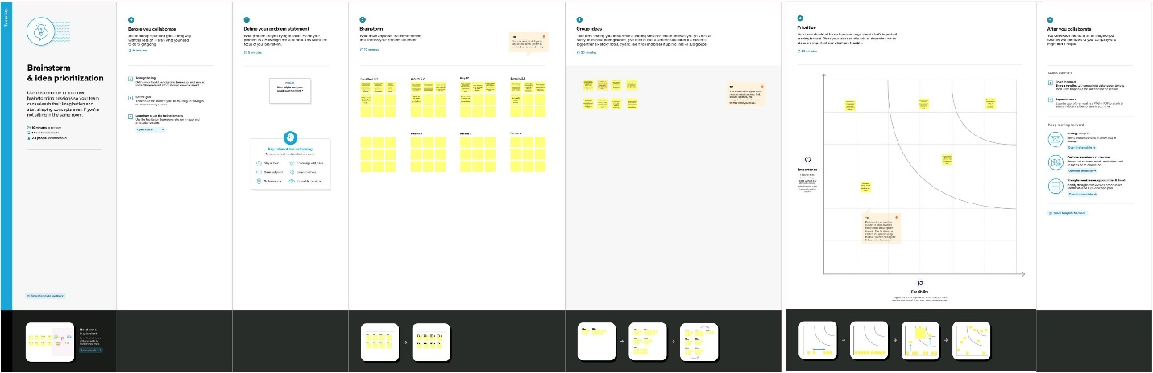

Result:

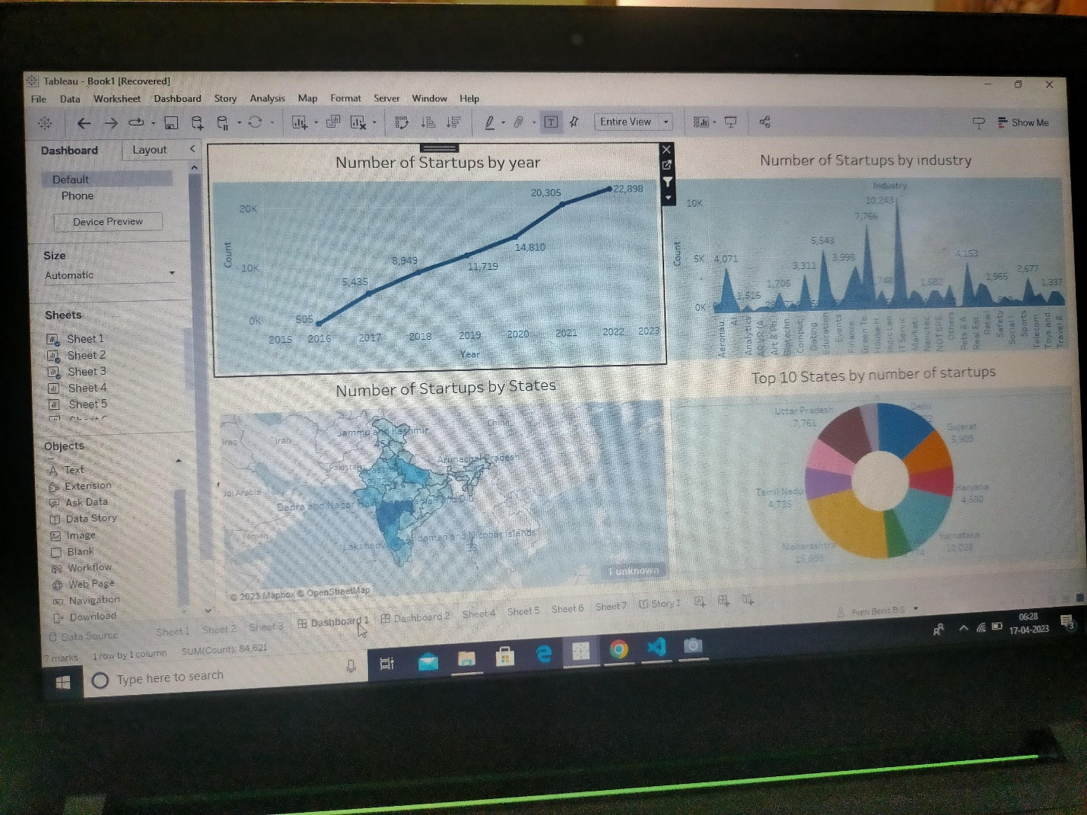Dashboard

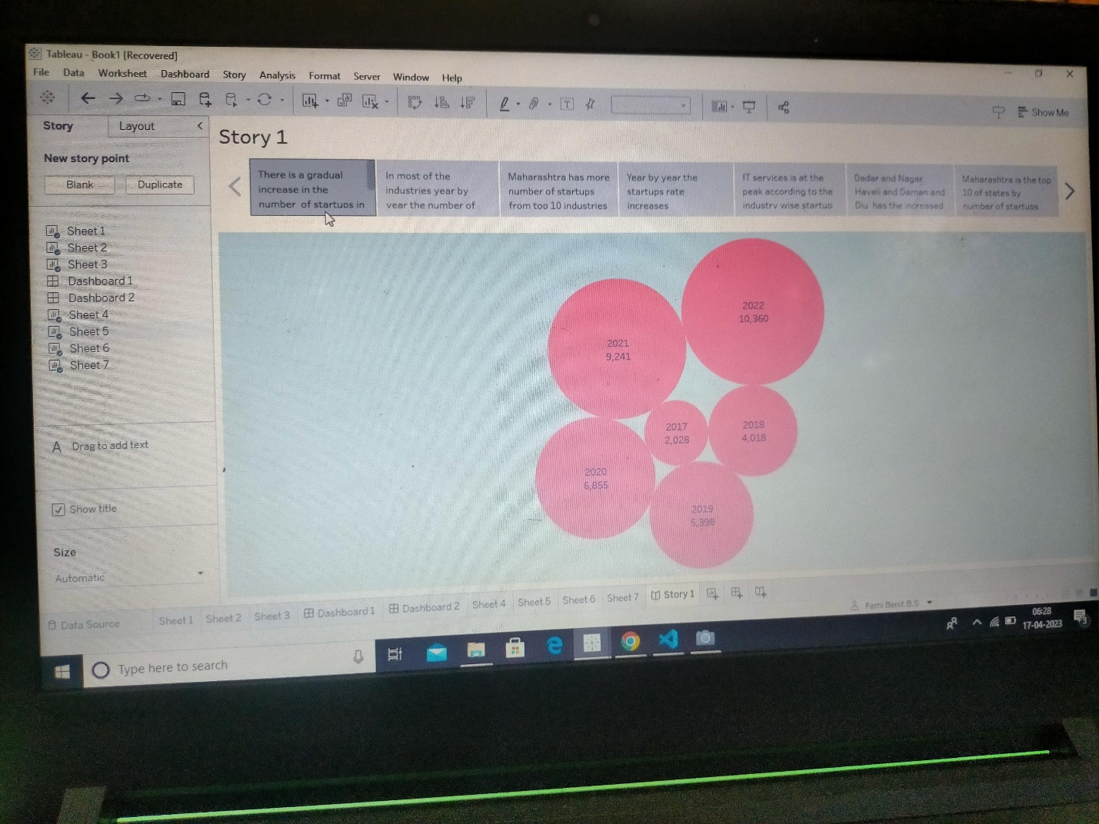Story

Advantages and Disadvantage:

Advantages:

\*Freedom and Flexibility. When you own a business, you are your own boss.

\*As the founder, your startup is based on your vision.

Disadvantages:

\*Most startups fail within their first year of operations, so the risk of failure is high. Working under such high risk can blur a startup’s strategic vision. So they either fail to seize market opportunities or overestimate their sales projections.

\*Money running out, being in the wrong market, a lack of research, bad partnerships, ineffective marketing, and not being an expert in the industry.

Applications:

\* Government also provides lists of facilitators of patents and trademarks. They will provide high-quality Intellectual Property Right Services including fast examination of patents at lower fees. The government will bear all facilitator fees and the startup will bear only the statutory fees. They will enjoy reduction in the cost of filing patents.

\*The government has proposed to hold 2 startup fests annually both nationally and internationally to enable the various stakeholders of a startup to meet. This will provide huge networking opportunities.

Conclusion:

A business plan conclusion is a summary of a business plan’s strengths designed to convince the reader of the company’s success. Because companies typically create business plans to get funding or investors, the conclusion should focus on how the organization makes money.

Future scope:

1. Increase in Globalization

A lot of factors, including globalization and the rise of the IT industry were majorly responsible for the rise of entrepreneurship in India. Higher pay scales with good designations offered by several private sectors or multinational companies encouraged the people.

1. Startup Ecosystem

The startup ecosystem is receiving a lot of support from international and Indian investors, who have increased trust in the sector and have committed funding to enable these businesses to develop. Today, the Indian economy is undergoing an immense makeover with new strategies rolling into the market emphasizing and enhancing the role and contribution of startups.

1. Make In India initiative

The government of India launched the “Make in India” project to encourage businesses to create, produce, and assemble goods in India and to encourage targeted investments in manufacturing. The goal of the strategy was to create a business-friendly atmosphere, buildup an effective infrastructure, and open up new markets to foreign investment.